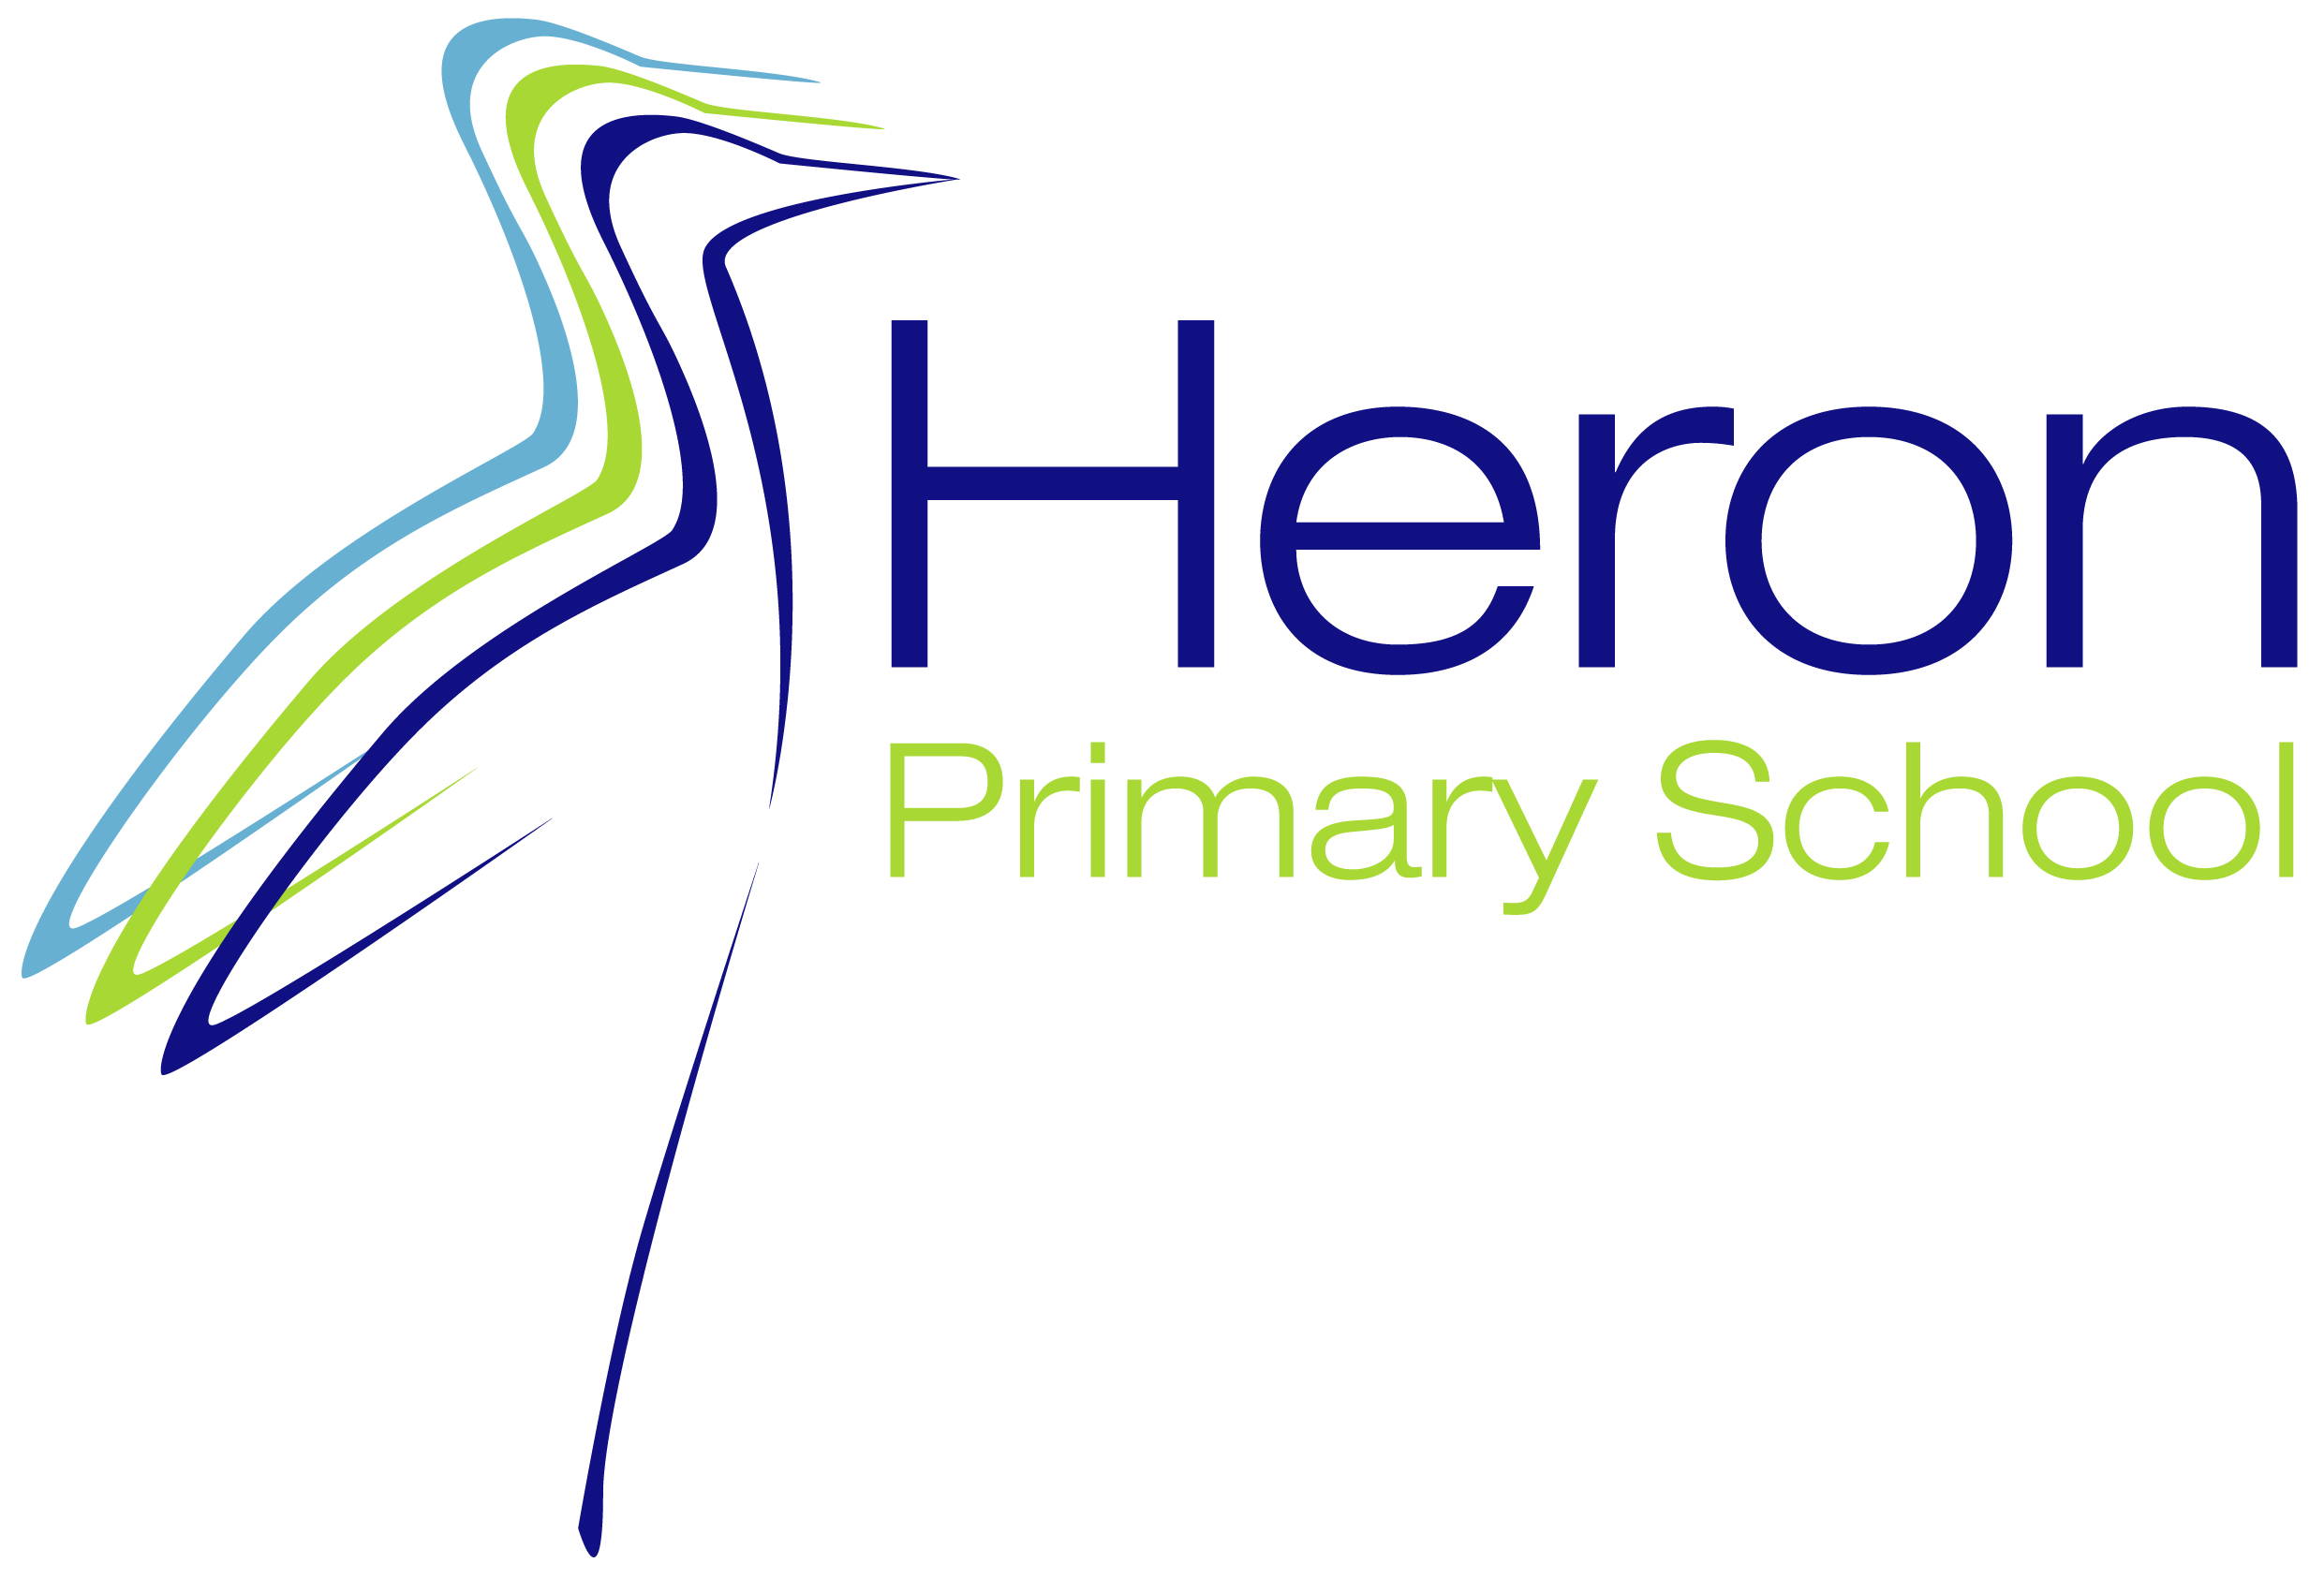

Relationship and Sex Education Policy

This policy was reviewed in Term 2 2024
and will be reviewed in line with the policy review timetable.

Relationship and Sex Education Policy

1 Introduction

  - Relationship and Sex Education is defined as ‘learning about physical, moral and emotional development. It is about understanding the importance of family life, stable and loving relationships, respect, love and care and growing up.’ Relationship and Sex Education is part of the Wellbeing Curriculum, Science, Religious Education (RE) and Physical Education (PE) in our school. While we use RSE to inform children about sexual issues, we do this with regard to matters of morality and individual responsibility, and in a way that allows children to ask and explore moral questions. We do not use RSE as a means of promoting any form of sexual orientation.

In line with the DfE 2019 Guidance, the focus of RSE at Heron Primary School will be on teaching the fundamental building blocks and characteristics of positive, healthy, respectful relationships, with particular reference to friendships, family relationships, and relationships with other children and with adults in all contexts, including online. This will sit alongside the essential understanding of how to be healthy and how totally interlinked physical and mental health are.
The key elements of Relationship Education have been divided into five sections:
- Families and people who care for me
- Caring friendships
- Respectful relationships
- Online relationships
- Being safe

2 Intent and objectives

2.1 By the End of Key Stage 1

Pupils will be able to:
- Recognise and compare the main external parts of the bodies of humans.
- Recognise similarities and differences between themselves and others and treat others with sensitivity.
- Identify and share their feelings with others.
- Recognise safe and unsafe situations.
- Identify and be able to talk with someone they trust.
- Be aware that their feelings and actions have an impact on others.
- Make a friend, talk with them and share feelings.
- Use simple rules for dealing with strangers and for resisting pressure when they feel uncomfortable or at risk.

Pupils will know and understand:
- That animals, including humans, grow and reproduce.
- That animals and humans can produce offspring and these grow into adults.
- The basic rules for keeping themselves safe and healthy.
- About safe places to play and safe people to be with.
- The needs of babies and young people.
- Ways in which they are liked and different from others.
- That they have some control over their actions and bodies.
- The names of the main external parts of the body including agreed names for sexual parts.
- Why families are special for caring and sharing.

Pupils will have considered:
- Why families are special.
- The similarities and differences between people.
- How their feelings and actions have an impact on other people.

By the end of Key Stage 2

Pupils will be able to:
- Express opinions, for example, about relationships and bullying.
- Listen to and support others.
- Respect other people’s viewpoints and beliefs.
- Recognise their changing emotions with friends and family and be able to express their feelings positively.
- Identify adults they can trust and who they can ask for help.
- To be self-confident in a wide range of new situations, such as seeking new friends.
- Form opinions that they can articulate to a variety of audiences.
- Recognise their own worth and identify positive things about themselves.
- Balance the stresses of life in order to promote both their own mental health and well-being and that of others.
- See things from other people’s viewpoints, for example their parents and their carers.
- Discuss moral questions.
- Listen to and support their friends and manage friendship problems.
- Recognise and challenge stereotypes, for example in relation to gender.

Pupils will know and understand:
- That the life processes common to humans and other animals include growth and reproduction.
- About the main stages of the human life cycle.
- That safe routine can stop the spread of viruses including HIV.
- About the physical changes that occur at puberty, why they happen and how to manage them.
- The many relationships in which they are all involved.
- Where individual families and groups can find help.
- How the media impact on forming attitudes.
- About keeping themselves safe when involved with risky activities.
- That their actions have consequences and be able to anticipate the results of them.
- About different forms of bullying people and the feelings of both bullies and victims.
- Why being different can provoke bullying and know why this is unacceptable.

Pupils will have considered:
- Others’ points of view, including their parents and carers.
- Why being different can provoke bullying and why this is unacceptable.
- When it is appropriate to take a risk and when to say no and seek help.
- The diversity of values and customs in the school and the community.
- The need for trust and love in established relationships.
- The diversity of lifestyles.

3 Context

3.1 While RSE in our school means that we give children information about sexual behaviour, we do this with an awareness of the moral code and values, which underpin all our work in school. In particular, we teach RSE in the belief that:
- It should be taught in the context of a loving stable relationship and family life.
- RSE is part of a wider social, personal, spiritual and moral education process.
- Children should be taught to have respect for their own bodies.
- Children should learn about their responsibilities to others.
- It is important to build positive relationships with others, involving trust and respect.

3.2
Research has shown that a comprehensive RSE curriculum can help young people to feel more positive about themselves and to understand what a healthy relationship looks like, as well as to delay the age at which they become sexually active. Young people who feel good about themselves are more knowledgeable and confident about relationships, more likely to be more discerning in their relationships and sexual behaviours and also more likely to have healthy, safe and fulfilling relationships.

3.3

Keeping Children Safe in Education (KCSIE) 2019 sets out that all schools and colleges should ensure children are taught about safeguarding, including how to stay safe online, as part of providing a broad and balanced curriculum, and our RSE curriculum at Heron Primary School is key to this provision. This may include covering relevant issues through Relationships Education (from 2020) and through Wellbeing. At the heart of these subjects there is a focus on keeping children safe, and schools can play an important role in preventative education.

4 Statutory Requirements

4.1 The Relationships Education, RSE, and Health Education (England) Regulations 2019 have made Relationships Education compulsory in all primary schools from September 2021. Sex Education is not compulsory in primary schools however puberty is covered in the Relationships and Health Education content and the Department for Education (DfE) continues to recommend that all primary schools should have a sex education programme tailored to the age and physical and emotional maturity of the pupils. In addition, the National Curriculum for science includes subject content in related areas, such as the main external body parts, the human body as it grows from birth to old age (including puberty) and reproduction in some plants and animals.
At Heron Primary School, we link this work in science to our Wellbeing curriculum around health and relationships and respond to our children’s questions in an age appropriate way. However, if a parent wishes to withdraw their child from sex education beyond the national curriculum for science, we uphold that right and would welcome a discussion around any concerns.

5 The National Healthy School Standard

5.1 We have achieved the National Healthy School Standard scheme, which promotes health education. As participants in this scheme we:
- Consult with parents on all matters of health education policy.
- Train our Year 6 teachers to teach RSE.
- Listen to the views of the children in our school regarding RSE.
- Look positively at any local initiatives that support us in providing the best RSE teaching programme that we can devise e.g. we receive guidance from the School Nurse and Health Authority.

6 Implementation and Impact

6.1 The main RSE programme will be taught within PSHCE lessons. Using the SCARF curriculum, it is taught discretely throughout the 6 units. In addition, certain biological aspects will be taught through science lessons and further elements of RSE will arise in other areas of the curriculum.
Should a teacher be absent, it would not be undertaken by a short-term supply teacher.

6.2 Ground rules Teachers are careful to ensure that their personal beliefs and attitudes do not influence the teaching of RSE. To this end, ground rules are always agreed upon to provide a common values framework within which to teach. There are clear parameters as to what will be taught in whole class setting and what will be dealt with on an individual basis.
Ground rules will ensure that:
- Pupils are given preparation so that they will know how to minimise any embarrassment they feel.
- No one (teacher nor pupil) should be expected to answer a personal question.
- No one will be forced to take part in a discussion.
- The school’s confidentiality/safeguarding policies are adhered to.

6.3 Answering difficult questions When delivering the RSE objectives (section 2) teachers will always consider how children of the same age may be developmentally at different stages, leading to differing types of questions or behaviours. Teaching methods should take account of those developmental differences (including when these are due to specific special educational needs or disabilities) and recognise the potential for discussion on a one-to-one basis or in small groups. Schools should consider what is appropriate and inappropriate in a whole-class setting, as teachers may require support and training in answering questions that are better not dealt with in front of a whole class. On occasion, an individual child will ask an explicit or difficult question in the classroom. Questions do not always have to be answered immediately; it may be more appropriate to address them later. At Heron Primary School we believe that individual teachers must use their skill and discretion in these situations and could refer to the Wellbeing subject leaders.

6.4 Dealing with questions
- Teachers should establish clear parameters about what is appropriate and inappropriate in a whole-class setting.
- Teachers should set the tone by speaking in a matter-of-fact way and ensure that pupils discuss issues in a way which does not encourage giggling and silliness.
- Pupils should be encouraged to write down questions anonymously and post them in a ‘problem/worry box’. The teacher will then have time to prepare age-appropriate answers to all questions before the next session and will choose not to respond to any questions which are inappropriate.
- Teachers should respond to questions where they can, always bearing in mind that pupils who do not have their questions answered may go online to find answers.
- Teachers should not be drawn into providing more information than is appropriate to the age of the child.
- If a verbal question is too personal, the teacher should remind the pupils of the ground rules.
- If a question is too explicit, feels too old for a pupil, is inappropriate for the whole class or raises safeguarding concerns, the teacher should acknowledge the question and promise to attend to it later, on an individual basis.
- Pupils must not be given the impression that teenagers inevitably have sex. The view that sex should be between two people who are mature enough to make informed decisions should be emphasised.
- If a teacher is concerned that a pupil is at risk of sexual abuse the head teacher should be informed and the usual safeguarding/child protection procedures followed.

7 Equal Opportunities

The law now states that all pupils should have access to Relationships Education and Health Education that is relevant to their particular needs. To achieve this, Heron Primary School’s approach to RSE will take account of:

7.1 Ethnic and cultural diversity
Different ethnic and cultural groups may have different attitudes to RSE. The school will consult pupils and parents/carers about their needs, take account of their views and promote respect for, and understanding of, the views of different ethnic and cultural groups.

7.2 Varying home backgrounds
We recognise that our pupils may come from a variety of family situations and home backgrounds. We shall always endeavour to prevent stigmatisation of children based on their home circumstances.

7.3 Sexuality
Some of our pupils will go on to define themselves as lesbian, gay, bi-sexual, transgender or questioning (LGBTQ). Pupils may also have LGBTQ parents/carers, brothers or sisters, other family members and/or friends. Eventually all our pupils will meet and work with LGBTQ people. Our approach to RSE will include sensitive, honest and balanced consideration of sexuality and we shall actively tackle homophobic or sexist bullying. We are working towards creating a gender-neutral environment, where each child is seen as an individual.

7.4 Special Educational Needs
We shall take account of the fact that some pupil may have learning, emotional or behavioural difficulties or physical disabilities that result in particular RSE needs.

8 A whole school approach

The school is well aware that the primary role in children’s RSE lies with parents and carers. We wish to build a positive and supporting relationship with the parents of children at our school through mutual understanding, trust and co-operation. In promoting this objective we take a whole school approach to teaching RSE.

8.1 Teaching staff are all involved in the school’s RSE provision; as well as delivering the curriculum, they all play an important pastoral role by offering support to pupils. Teachers will be consulted about the school’s approach to RSE and aided in their work by provision of resources, background information, and access to appropriate training, support and advice from experienced members of staff.

8.2 Non-teaching staff may be involved in a supportive role in some RSE lessons and also play an important (formal or informal) pastoral support role with pupils. They will have access to information about the RSE programme and be supported in their pastoral role.

8.3 Governors have responsibilities for school policies. They will be consulted about the RSE provision and policy.

8.4 Parents/carers have a legal right to have information about the school’s RSE provision. They may have access at any point to the programme of work and are invited to come into school to discuss the content of the lessons and to view the resources used. The class teacher or Wellbeing subject leaders would be willing to work with them at any point, However, under the new statutory guidance, parents cannot withdraw their children from Relationships Education. As stated in section 4 above, they may only withdraw their child from sex education beyond the national curriculum for science. The school will, however, seek and take account of parent/carer views and endeavour to adopt a partnership approach with parents/carers; we will take time to address concerns and allay any fears.

8.5 Outside agencies and speakers may be involved in contributing to RSE lessons. The school will only work with agencies and speakers who are appropriate to the pupils’ needs. In particular, members of the Local Health Authority, such as the school nurse and the Life in Education bus, give us valuable support with our RSE programme. Other people that we call on include local clergy, Social workers and Youth workers.

8.6 Pupils have an entitlement to RSE and pastoral support appropriate to their age and circumstance. They will be consulted about their RSE needs and their views will be central to developing the provision.

9 Confidentiality

9.1 Teachers conduct RSE lessons in a sensitive manner and in confidence. Good RSE practise allows children an open forum to discuss potentially sensitive issues. Such discussions can lead to increased safeguarding reports. If a child makes a reference to being involved, or likely to be involved in sexual activity, then the teacher will take the matter seriously and deal with it as a matter of child protection. Teachers will respond in a similar way if a child indicates that they may have been a victim of abuse. (See Child Protection Policy) In these circumstances the appropriate procedure will be followed. If the teacher has concerns, they will draw their concerns to the attention of the Headteacher.

10 The role of the Subject Leaders

10.1 It is the responsibility of the Subject Leaders to ensure that both staff and parents are informed about our RSE Policy, and that the policy is implemented effectively. The SMT Manager responsible for staff training needs to ensure that members of staff are given sufficient training if and when courses become available, so that they can teach effectively and handle any difficult issues with sensitivity.

10.2 The Subject Leader/Class teacher liases with external agencies regarding the school RSE programme, and ensures that all adults who work with children on these issues are aware of the school policy, and that they work within this framework.

10.3 The Subject Leader monitors this policy with the staff on a regular basis and reports to governors, when requested, on the effectiveness of the policy.

11 Monitoring and review

11.1 The Curriculum Committee of the Governing Body monitors our RSE Policy in line with the School Action Plan. This committee reports its findings and recommendations to the full governing body, as necessary, if the policy needs modification. The Curriculum Committee gives serious consideration to any comments from parents about the RSE programme, and makes a record of all such comments.

See Appendices
Appendix 1: Further support for Relationship and Sex Education.

Links to the Following Policies:
Behaviour/Anti-Bullying Policy.
Equal Opportunities Policy.
Science Policy.
Religious Education Policy
PSHCE Policy.
Child Protection Policy

P/sexandrelationshipedpol

Appendices

Additional support and information for Relationship and Sex Education

National

Sex Education Forum
Tel No: 020 7843 6052 or website www.ncb.org.uk/sexed.htm

Other key websites
www.wiredforhealth.gov.uk
www.dfes.gov.uk
www.qca.org.uk
www.ofsted.gov.uk
www.nc.uk.net

Local

Gloucestershire Healthy School Partnership 01452 425450
Sexual Health Promotions Team 01452 429342
School Nurse Liaison 01452 425450
Resources- teaching packs etc 01452 425119
Health Promotion Resource Service 01452 429 363
Library Service for Education 01452 427241

